BSCS FINAL PROJECT

Multi Crop Disease Detector



Prof. Ahmad Nazir

MCDD v-1.0

Presented by:

F21-BSCS-5008 Iqra Khadim
F21-BSCS-5080 Bushra Hanif
F21-BSCS-5046 Muhammad Saleem

Department of Computer Science

Faculty of Computing

University of Okara

Table of Contents
1. Introduction 1
1.1 Product 1
1.2 Scope 1
1.3 Business Goals 2
1.3.1 Early Detection of Crop Diseases 2
1.3.2 Reduce Crop Losses and Economic Burden 2
1.3.3 Promote Smart and Data-Driven Agriculture 2
1.3.4 Increase Access to Expert Knowledge via Technology 2
1.4 Document Conventions 2
2. Project Description 3
2.1 Overall Description 3
2.1.1 Product Features 3
2.1.2 User Classes and Characteristics 3
2.1.3 Operating Environment 5
2.1.4 Design and Implementation Constraints 6
2.2 Functional Requirements 9
2.2.1 Use-Case 1: Detect Disease from Crop Image 9
2.2.2 Use-Case 2: View Detection History and Disease Details 10
2.3 Nonfunctional Requirements 10
2.3.1 Performance Requirements 10
2.3.2 Safety Requirements 11
2.3.3 Security Requirements 12
2.3.4 Software Quality Attributes 13
2.4 Other Requirements 14
3. Analysis Models 16
3.1 Use-case Diagram (UCD 1) 16
3.1.1 Purpose of the Diagram 16
3.1.2 System Boundary 16
3.1.3 Actors 16
3.1.4 Use Cases: Detect Disease from Crop Image 17
3.1.5 Relationships 18
3.2 Use-case Diagram (UCD 2) 19
3.2.1 Purpose of the Diagram 19
3.2.2 Actors 19
3.2.3 Use Cases: View Detection History and Disease Details 19
3.2.4 Relationships 21
3.3 Entity-Relationship Diagram (ERD) 22
3.3.1 Purpose of the Diagram 22
3.3.2 Entities 22
3.3.3 Relationships 23
3.4 Sequence Diagram 25
3.4.1 Purpose of the Diagram 25
3.4.2 Participants 25
3.4.3 Message Flow (Interaction Sequence) 26
4. Design Models 28
4.1 Component diagram 28
4.1.1 Purpose of the Diagram 28
4.1.2 Components 28
4.1.3 Component Interactions and Dependencies 29
4.1.4 Logical Grouping 30
4.2 Deployment Diagram 31
4.2.1 Purpose of the Diagram 31
4.2.2 Nodes 31
4.2.3 Deployed Components 32
4.2.4 Communication Links 32
5. Screenshots 34
5.1 Home Screen 34
5.1.1 Workflow 34
5.2 About Screen 42
5.2.1 Workflow 42
5.3 History Screen 46
5.3.1 Workflow 46
5.4 Diseases Screen 48
5.4.1 Workflow 48
5.5 Details Screen 51
5.5.1 Workflow 51
6. Test Cases 54
6.1 Test Case 1: Image Upload and Prediction 54
6.2 Test Case 2: View Detection History and Disease Details 55
6.3 Test Case 3: Viewing Saliency Map Overlays 56
6.4 References 57

List of Figures
Figure 1: Use Case-1: Detect Disease from Crop Image 18
Figure 2: Use Case-2: View Detection History and Disease Details 21
Figure 3: Entity-Relationship Diagram (ERD) for Model Training and Evaluation 24
Figure 4: Sequence Diagram - Real-Time Disease Detection Workflow 27
Figure 5: Component Diagram - System Architecture Overview 30
Figure 6: Deployment Diagram - Physical System Architecture 33
Figure 7: Home Screen 35
Figure 8: Home Screen - Selecting the Image 36
Figure 9: Home Screen - Selected Image Loaded, Awaiting Upload for Detection 37
Figure 10: Home Screen - Image Uploaded, Awaiting Prediction Results 38
Figure 11: Home Screen - Prediction Result 39
Figure 12: Home Screen - Prediction Result with top 3 predictions 40
Figure 13: Home Screen - Saliency Maps 41
Figure 14: About Screen 43
Figure 15: About Screen - About the project 44
Figure 16: About Screen - Feedback/ Get in touch 45
Figure 17: History Screen 47
Figure 18: Disease Screen/ Corn, Potato 49
Figure 19: Disease (Wheat, Tomato) 50
Figure 20: Disease Details 52
Figure 21: Disease Details 53

Introduction

Product
The Multi-Crop Disease Detector is an AI-powered mobile application designed to detect and identify crop diseases from images. The system uses deep learning techniques, specifically convolutional neural networks (CNNs), to analyze images of crops and classify them into specific disease categories. Farmers can upload images through the app to receive real-time feedback on the detected disease and confidence score. This mobile-based solution is developed to assist farmers and agricultural workers by providing early and accurate disease detection, helping them take timely action. The current version of the system focuses solely on disease detection; treatment recommendations and future prediction features are planned for later stages.

Scope
This project will focus on the development of a crop disease detection system capable of identifying the following diseases in the specified crops:
- Potato: Late Blight, Early Blight
- Wheat: Yellow Rust, Brown Brust
- Maize (Corn): Gray Leaf Spot, Leaf Blight, Common Rust
- Tomato: Late Blight, Early Blight
The scope of the project includes:
- Acquisition and preprocessing of image datasets, including the Plant Village Dataset, the Plant Diseases Training Dataset, and the Five Crop Diseases Dataset.
- Design, development, and experimentation with deep learning models for image-based disease detection. This project follows a research-driven approach, testing different architectures, including custom-built CNNs and optimized pre-trained models. The final model selection will be based on accuracy, efficiency, and feasibility after iterative experimentation.
- Design and implementation of a user-friendly interface for image upload and disease diagnosis.
- Evaluation and testing of the system's performance and accuracy.

Business Goals
The following business and social goals are addressed by the Multi-Crop Disease Detector software:

Early Detection of Crop Diseases
To enable timely and accurate identification of plant diseases, allowing farmers to take corrective action before major crop damage occurs.

Reduce Crop Losses and Economic Burden
To minimize financial losses faced by farmers due to undetected or late-detected diseases, improving overall agricultural productivity.

Promote Smart and Data-Driven Agriculture
To empower farmers and agronomists with AI-driven tools that support informed decision-making, particularly in rural and under-resourced areas.

Increase Access to Expert Knowledge via Technology
To provide disease detection capabilities through a mobile application, making expert-level assistance accessible to farmers without requiring physical field visits.

Document Conventions
This Software Requirements Specification (SRS) uses the following conventions:
- Bold text is used for section headings and important terms
- Italic text is used for optional or secondary features
- Code-related terms (e.g., CNN, API) are written in inline monospace formatting
- All acronyms are introduced with full forms upon first use (e.g., Convolutional Neural Network (CNN))
- Use case identifiers are formatted as UC-01, UC-02, etc.
- Diagrams are referenced by figure number and title in the final document

Project Description

Overall Description

Product Features
The Multi-Crop Disease Detector application offers the following core features and functionalities:
- Image-Based Disease Detection: Users can capture or upload images of crop leaves to detect diseases using a deep learning model (CNN). The model analyzes the image and classifies it into a specific disease category.
- Confidence Score Display: After classification, the system displays the detected disease along with a confidence score indicating the model’s certainty.
- Mobile Application Interface: A user-friendly mobile app is developed to provide easy access to disease detection features, designed specifically for farmers with minimal technical skills.
- Multi-Crop Support: The system supports disease detection for multiple crops, including:
  - Potato
  - Wheat
  - Maize
  - Tomato
- Cloud-Based Model Processing: All image classification is performed on the backend/cloud server, allowing the app to run on low-resource mobile devices without requiring local AI processing.
- Result History: The system maintains a local or cloud-based history of previous disease detection results for user reference (if implemented).

User Classes and Characteristics
The Multi-Crop Disease Detector is designed to serve three primary user classes, each with different technical backgrounds, usage goals, and interaction levels with the system:

Farmers (Primary Users)

- Frequency of Use: Regular or seasonal
- Technical Expertise: Low
- Educational Level: Varies; often limited digital literacy
- Access Level: Basic user
- Characteristics:
  - Use the mobile app to upload crop images for disease detection.
  - Rely on the app’s simplicity and ease of navigation.
  - Prefer results in clear language with visual feedback (e.g., disease name, confidence score).
  - Favored user class, the app is primarily designed with farmers in mind.

Agronomists and Agricultural Experts

- Frequency of Use: Occasional
- Technical Expertise: High
- Educational Level: Advanced (e.g., BS/MS in Agriculture)
- Access Level: May have access to advanced disease records and analytics (if implemented).
- Characteristics:
  - Use the system to validate field diagnoses and assist farmers.
  - May contribute feedback to improve the app’s performance or suggest disease updates.

Researchers and Developers

- Frequency of Use: Project-based or academic research
- Technical Expertise: Very high
- Educational Level: Graduate or postgraduate level (CS, AI, Agriculture)
- Access Level: Extended could involve access to model statistics, dataset usage, or system logs (if exposed).
- Characteristics:
  - Use the system for evaluation, improvement, or integration into larger research workflows.
  - Less favored in terms of UI design but important for long-term scalability and enhancements.

Operating Environment
The Multi-Crop Disease Detector is developed primarily for Android-based mobile devices and designed to operate in environments where farmers or users have access to smartphones and internet connectivity. The application and its components interact with cloud-hosted AI services to perform disease detection. The following describes the key elements of the operating environment:

- Mobile Application
  - Platform: Android
  - Development Framework: React Native (with Expo)
  - Minimum OS Version: Android 7.0 (Nougat)
  - Functionality: Allows users to upload or capture images of crops and view the prediction results from the AI model in real time.
  - Internet Requirement: Required for sending images to the backend and receiving predictions.
- Model Development and Training
  - Dataset Preprocessing: Conducted using Google Colab (Python, NumPy, Pandas, OpenCV)
  - Model Training Environment: Trained on Kaggle Notebooks using GPU acceleration
  - Model Architecture: Custom Branched CNN developed in PyTorch, supporting multiple kernel sizes for enhanced feature extraction and disease classification
- Model Deployment
  - Model Host: Hugging Face Inference API (for real-time cloud inference)
  - Model Format: PyTorch (.pt) converted and hosted in a Hugging Face-compatible format
  - Inference Mode: Cloud-based, the mobile app sends an image to the backend, which relays it to the Hugging Face model API for prediction
- Backend Services
  - Framework: FastAPI (Python)
  - Responsibilities: Handles image input, preprocessing, and routing to Hugging Face model, Parses and returns prediction results to the mobile app
- Additional Tools & Dependencies
  - Cloudinary: Used for storing images and saliency maps
  - TorchVision / NumPy / PIL: Used in preprocessing pipelines
  - Mobile Network Requirements: Minimum stable 3G or 4G internet for smooth image transfer and response fetching

Design and Implementation Constraints
The development of the Multi-Crop Disease Detector faced several design and implementation constraints that influenced both the system architecture and final feature set. These constraints include technical, computational, and dataset-related limitations:

Real-World Dataset Limitations

- Most available datasets (like PlantVillage) contain lab-quality images with plain backgrounds, which do not fully represent real-world conditions such as shadows, dirt, multiple leaves, or damaged crops.
- Public datasets lacked some specific crop-disease combinations relevant to the local context (e.g., Pakistani crop variants), which limited model generalization.
- Dataset class imbalance also impacted training, some diseases had far fewer images than others.

Hardware Limitations

- Due to lack of access to high-performance local machines, model training was done on Kaggle Notebooks using time-limited GPU sessions.
- Preprocessing was handled separately on Google Colab due to memory constraints and session timeouts on free platforms.
- These limitations restricted the use of very large or deeper neural networks, and constrained the number of training epochs (20 Epochs) and batch sizes.

Model Deployment Constraints

- The trained model was deployed using Hugging Face Spaces, which has request limits and response time constraints in free-tier usage.
- Real-time inference depends on a stable internet connection, which may not always be available to rural users.

Mobile App Performance

- Since image processing is handled in the cloud, the app had to be optimized to compress and send images efficiently without loss of classification accuracy.
- Target devices are low-cost Android phones with limited RAM and processing power, restricting any local model inference or heavy computation on the device.

Technology Stack Limitations

- FastAPI backend was chosen for its simplicity and speed, but it required custom integration for communicating with Hugging Face and Cloudinary.
- PyTorch model had to be adapted for web-based deployment, which involved size optimizations and format conversions.
- Limited team size and time prevented integration of some planned features (e.g., treatment recommendation module, admin dashboard).

Security and Data Privacy

- Since images are sent to the cloud, image encryption and privacy were considered, but complete user consent mechanisms and GDPR-compliance systems were not implemented due to time constraints.
- Multi-user authentication with roles (e.g., farmer, researcher) is planned but currently not fully functional.

Assumptions and Dependencies

The development and successful operation of the Multi-Crop Disease Detector system rely on several key assumptions and external dependencies. Any changes or violations of these assumptions could affect the functionality, reliability, or delivery timeline of the project.

Assumptions

- Internet Access: It is assumed that users (especially farmers) will have access to a stable internet connection to upload images and receive disease detection results from the cloud.
- Image Input Quality: The system assumes that users will upload reasonably clear and focused images of crop leaves for accurate detection. Blurred or irrelevant images may cause detection errors.
- Mobile Device Capabilities: The application assumes users will have Android smartphones with:
  - Minimum Android 7.0
  - A functioning rear camera (≥5 MP resolution)
  - Enough storage to install and run the app
- Cloud Service Availability: It is assumed that Hugging Face, FastAPI, and other cloud-based services (like Cloudinary, if used) will remain online and maintain consistent uptime for inference, image storage, and communication.
- English Language Understanding: It is assumed that users can understand basic English terms like disease names and confidence scores. Future localization (Urdu, etc.) is planned but not currently implemented.

Dependencies

- Pre-trained and Public Datasets:
The model depends on external datasets sourced from:
  - PlantVillage Dataset
  - Plant Diseases Training Dataset
  - Five Crop Diseases Dataset (Kaggle)
  - If these datasets are taken down, restricted, or updated, retraining the model may be required.
- Third-party Hosting (Hugging Face): The trained PyTorch model is deployed on Hugging Face, which is a third-party platform with usage limits, API call restrictions, and possible downtime that may affect the real-time detection functionality.
- Backend Server (FastAPI): The backend service depends on the availability and performance of FastAPI routes for image handling and prediction response. Any failure or downtime in this layer could cause the entire system to become unresponsive.
- Google Colab and Kaggle Notebooks: During development, model training and data preparation were dependent on Google Colab and Kaggle platforms. Any future retraining will continue to rely on these resources unless an alternative GPU infrastructure is available.
- Mobile App Integration with APIs: The React Native mobile app depends on the correct functioning of APIs for disease prediction. Any changes in API endpoints, formats, or authentication protocols would require updates to the app.

Functional Requirements

Use-Case 1: Detect Disease from Crop Image
Identifier |  | UC-1
Purpose |  | To detect the disease in a crop leaf by analyzing an uploaded image using an AI model
Priority |  | High
Pre-conditions |  | Device must be connected to the internet  Device must have a functioning camera or access to photo gallery
Post-conditions |  | System returns the predicted disease and confidence score  Result is displayed on-screen and stored in user history
Typical Course of Action
S# | Actor Action |  | System Response
1 | User opens the app and navigates to the “Home” screen |  | App loads the image upload interface
2 | User uploads or captures a crop image |  | System prepares the image and sends it to the backend server
3 | User taps the “Upload Image” button |  | Backend forwards image to the model hosted on Hugging Face
4 | . |  | Model returns prediction result with a confidence score
Alternate Course of Action
S# | Actor Action |  | System Response
1 | User uploads a very poor or irrelevant image (e.g., blurry, not a crop) |  | System still processes the image but may return incorrect or uncertain prediction
2 | User observes that the result is unclear or irrelevant |  | User may manually retry by uploading a clearer image
Table 2.1: UC-1: Detect Disease from Crop Image

Use-Case 2: View Detection History and Disease Details

Identifier |  | UC-2
Purpose |  | To allow the user to view previously detected diseases along with their details such as symptoms and treatments
Priority |  | Medium
Pre-conditions |  | The user has previously submitted at least one image  Detection history is available and stored locally
Post-conditions |  | The user views a list of previous results  Upon tapping an entry, the app shows symptoms and treatment of that disease
Typical Course of Action
S# | Actor Action |  | System Response
1 | User opens the app and navigates to “History” screen |  | App loads the list of past disease predictions
2 | User scrolls or navigates back |  | App maintains session or allows back navigation to main screen
Alternate Course of Action
S# | Actor Action |  | System Response
1 | User opens history screen with no previous results |  | App displays message: “No history found” or “Start by detecting a disease”
2 | User taps back or navigates to detection screen |  | App redirects to detection screen
Table 2.2: UC-2: View Detection History and Disease Details

Nonfunctional Requirements

Performance Requirements
The performance of the Multi-Crop Disease Detector must ensure timely, responsive, and accurate feedback to users under typical usage conditions. The following performance requirements apply.

Inference Time

- The total time between image upload and receiving prediction should not exceed 5 seconds under normal network conditions (4G or broadband).
- This includes:
  - Image transfer from app to backend (FastAPI)
  - Communication with Hugging Face-hosted model
  - Receiving and displaying the result in the app
- Rationale
A delay beyond 5 seconds may degrade user experience, especially for farmers using the app in the field.

App Responsiveness

- All UI screens should load within 1 second under normal device conditions (RAM ≥ 2 GB).
- Tapping buttons like "Select Image", "Upload", and "History" should give immediate visual feedback (loading spinner, scrolling, etc.).
- Rationale: Ensures usability on low-to-mid-range Android devices commonly used in rural areas.

Accuracy Threshold

- The system aims to maintain a minimum classification accuracy of 80% on real-world images (test set).
- This is based on model evaluation using images not seen during training and representing varied lighting and backgrounds.
- Rationale: A threshold ensures the model is practically useful and trustworthy in the field.

Network Dependency

- The app must handle temporary network delays gracefully (e.g., display loading screen).
- Maximum retry wait time should not exceed 10 seconds before showing a timeout message.
- Rationale: In rural areas, intermittent internet is common, so graceful failure handling is essential.

Safety Requirements
Although the Multi-Crop Disease Detector is a software-based mobile application, certain safety-related considerations must be addressed to ensure the system does not lead to harm or misuse, especially in a sensitive domain like agriculture.

- Misdiagnosis Risk
  - The system must clearly indicate that the predicted result is AI-generated and not a medical or expert-certified diagnosis.
  - The app must display a disclaimer stating that predictions should be verified by an agronomist in case of uncertainty or severe crop damage.
  - Users should be discouraged from making high-risk decisions (e.g., pesticide use or large-scale crop removal) based solely on AI output.
  - Safeguard: Include a visible note or warning message on the results screen.
- Incomplete or Incorrect Information
  - The app must not display incorrect or misleading treatment advice, especially if not backed by verified agricultural sources.
  - Until a validated treatment recommendation system is implemented, the app should not suggest chemical names or dosages.
  - Action Taken: Treatment suggestion module is deferred to future updates and currently not part of the system.
- Data Loss or Corruption
  - Uploaded images and prediction history must be safely handled to avoid accidental loss or corruption of user data.
  - If a database or cloud storage is used (e.g., Cloudinary), proper backup and version control practices must be followed.
  - Safeguard: Implement data validation and fallback options in the backend for upload failures.
- Compliance with Ethical AI Use
  - The application must follow responsible AI practices, especially for transparency and user consent.
  - The app should not collect or share sensitive information (user location, field coordinates, or biometric data) without explicit permission.
  - Reference Policy: Basic compliance with data protection policies (like GDPR) is encouraged even if not legally required.

Security Requirements
The Multi-Crop Disease Detector handles sensitive data such as user-uploaded images, prediction history, and potentially identifiable user accounts. Therefore, several security and privacy measures are necessary to ensure safe operation and protect user trust.

- Data Privacy
  - All user-uploaded crop images must be treated as private data and must not be publicly accessible without explicit consent.
  - If stored (locally or in the cloud), images should be stored using secure URLs with access controls (e.g., Cloudinary private mode).
  - The system must not share user data with third parties.
  - Safeguard: Use secure APIs for file uploads and disable public access to raw image URLs.
- Secure Communication
  - All communication between the mobile app, backend (FastAPI), and model server (Hugging Face) must use HTTPS to prevent man-in-the-middle attacks.
  - API keys or tokens used for services (e.g., Hugging Face, Cloudinary) must be securely stored and not hardcoded in the mobile app.
- Protection Against Misuse
  - The system should include basic rate limiting or abuse prevention mechanisms to avoid:
  - Excessive image uploads from a single user
  - Unauthorized scraping or API flooding
  - Solution: Use request throttling and validation on FastAPI routes.
- Regulatory Considerations
  - Although not required by law, the app is designed to align with best practices for data protection, including principles from:
  - General Data Protection Regulation (GDPR) for user consent and transparency
  - Pakistan’s Personal Data Protection Bill (if enforced in future)

Software Quality Attributes
The following software quality attributes are critical to the success and long-term maintainability of the Multi-Crop Disease Detector application. These attributes ensure the product remains effective, scalable, and user-friendly under typical usage conditions.

- Usability
- The app is designed to be simple, intuitive, and operable by users with minimal technical experience (e.g., farmers).
- All core actions (image upload, detection, result viewing) are accessible within 3 taps.
- Visual feedback (loaders, error messages) is used to guide users through each process.
- Priority: Very High
- Availability
- The application and backend services are intended to be accessible 24/7, assuming the availability of cloud resources and internet connectivity.
- Target uptime: 99% availability, except during planned maintenance or API outages.
- Priority: High
- Reliability
- The app must function consistently during each use, returning accurate predictions given valid inputs.
- Upload and response failures should occur in <1% of sessions.
- Priority: High
- Portability
- The mobile app is designed for Android 7.0+ and should run without modification on a wide range of devices.
- Future versions will be adapted for iOS, using React Native’s cross-platform support.
- Priority: Medium
- Maintainability
- The backend code (FastAPI) and model pipeline (PyTorch) follow modular design principles.
- Clear documentation and consistent naming conventions are maintained to ensure ease of future updates or model retraining.
- Priority: High
- Scalability
- The system is designed to scale with an increase in users, with API load balancing and external model hosting (Hugging Face) in place.
- Architecture supports future expansion, such as adding disease prediction, multi-language support, or more crops.
- Priority: Medium
- Testability
- Each component (image upload, API request, model output) can be independently tested during development.
- Future versions will include unit tests and integration tests for better CI/CD practices.
- Priority: Medium

Other Requirements
This section outlines additional requirements not covered in the earlier sections but necessary for the effective functioning and future enhancement of the Multi-Crop Disease Detector application.

- Database Requirements
  - If implemented, the system should store the following data:
    - User-uploaded images (or their secure URLs)
    - Prediction results (disease name, confidence score, timestamp)
    - User profile information (if login is enabled)
  - The database must be scalable and secure, supporting encrypted data storage.
  - Future versions may use Firebase, PostgreSQL, or MongoDB for structured data handling.
- External Interfaces
  - Model Interface: The app must communicate with the Hugging Face model via REST API.
  - Cloud Storage Interface: Integration with image storage services like Cloudinary or Firebase Storage (optional) for handling image uploads.
  - Mobile–Backend Interface: FastAPI must expose secure endpoints for the mobile app to:
    - Upload images
    - Receive predictions
    - Retrieve prediction history
- Localization and Internationalization
  - The current version is in English only.
  - Future releases will support Urdu and other local languages to enhance accessibility for non-English-speaking users.
- Legal and Ethical Compliance
  - The system must not collect personal or sensitive data without user consent.
  - The app should clearly state that the results are AI-generated predictions and not a replacement for expert agricultural consultation.
  - The system should aim to comply with emerging data protection laws, including:
    - Pakistan's Personal Data Protection Bill
    - Global best practices like GDPR (for user consent and data control)
- Reusability Objectives
  - The codebase (model and backend) is designed to be modular and reusable.
  - The current CNN architecture (TheHulkNet) can be adapted to other crops or detection tasks by retraining with a different dataset.

Analysis Models
This section includes various analysis models that describe the functional behavior of the system. As the project is research and model-development focused, only the relevant diagrams have been created.

Use-case Diagram (UCD 1)
This section provides a detailed explanation of the Use Case Diagram for the Multi Crop Disease Detection System. A Use Case Diagram is a high-level behavioral diagram in UML (Unified Modeling Language) that illustrates the functionality of a system from an external point of view. It describes what the system does to provide value to its users (actors) and other external systems, without detailing how that functionality is implemented.

Purpose of the Diagram
The primary purpose of this Use Case Diagram is to:

- Identify the main actors interacting with the Multi Crop Disease Detection System.
- Define the key functionalities (use cases) that the system offers to these actors.
- Show the relationships between actors and the use cases they participate in.
- Establish the scope and boundaries of the system being developed.

System Boundary
The shaded rectangle in the diagram represents the System Boundary of the "Multi Crop Disease Detection" application. This boundary defines what is considered part of our system and what is external to it. All the functionality (use cases) provided by our application resides within this boundary.

Actors
Actors are entities that interact with the system from outside its boundary. They can be human users, other systems, or even hardware. In this diagram, we have identified two primary actors:

- Farmer:
  - Description: The primary human user of the system. The Farmer interacts with the mobile application to seek predictions regarding crop diseases.
  - Role: Initiates requests for disease prediction, provides input (crop images), and consumes the results provided by the system. The farmer is the end-user who derives direct value from the system's core functionality.
- Cloudinary:
  - Description: An external, third-party cloud-based image and video management service. Our system integrates with Cloudinary to handle the storage and delivery of images and generated saliency maps.
  - Role: Provides image storage services to our system and returns accessible links (URLs) for the stored content. It acts as a crucial external dependency for persistent storage of visual data.

Use Cases: Detect Disease from Crop Image
Use cases represent a specific goal that an actor achieves by interacting with the system. They describe a sequence of actions that produce a measurable value to an individual actor.

- Get Crop Disease Prediction:
  - Description: This is the primary and most comprehensive use case for the Farmer actor. It describes the entire process a farmer undertakes to get a diagnosis for a potential crop disease from the system. This use case starts when the farmer decides to analyze an image and concludes when they receive the prediction results.
  - Flow of Events:
    - The Farmer initiates a prediction request through the mobile application.
    - The Farmer selects an image of the affected crop (either from their device's gallery or by capturing a new photo).
    - The Farmer uploads the selected image to the system.
    - The system processes the image internally (involving the CNN model).
    - The system stores the original image and generated saliency maps (via Cloudinary).
    - The system provides the prediction results (including the disease diagnosis and links to the saliency maps) back to the Farmer.
  - Actors Involved: Farmer
- Manage Image and Saliency Map Storage:
  - Description: This use case describes the interaction between our "Multi Crop Disease Detection System" and the external Cloudinary service. It represents the system's goal of persistently storing the input images and the generated saliency maps for future reference or analysis.
  - Flow of Events:
    - The system (specifically, the backend server) sends the processed image and the generated saliency map to Cloudinary.
    - Cloudinary receives and stores these visual assets.
    - Cloudinary provides unique, accessible links (URLs) for the stored image and saliency map back to the system.
  - Actors Involved: Cloudinary (as the external system providing the service).

Relationships
- Association: The lines connecting actors to use cases are called associations. They indicate that an actor participates in or initiates a particular use case.
  - The line between Farmer and Get Crop Disease Prediction indicates that the Farmer is the primary initiator and beneficiary of this use case.
  - The line between Cloudinary and Manage Image and Saliency Map Storage indicates that our system interacts with Cloudinary to achieve the goal of storing and retrieving image data.
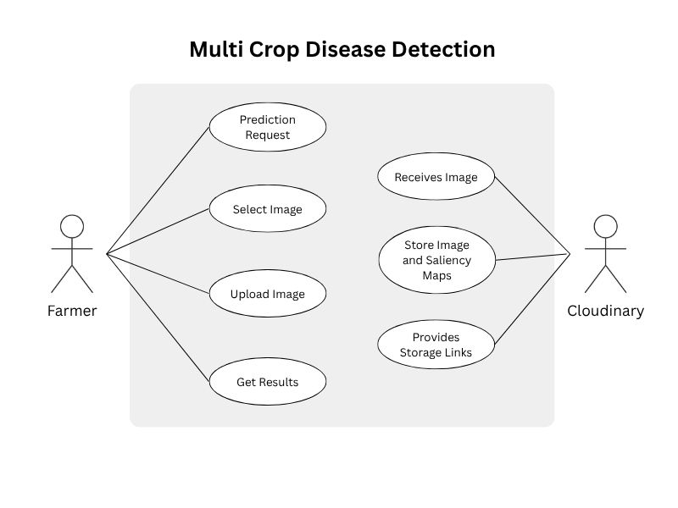
Figure 1: Use Case-1: Detect Disease from Crop Image

Use-case Diagram (UCD 2)
This section provides a detailed explanation of the refined Use Case Diagram for the Multi Crop Disease Detection System. This diagram, a key component of UML (Unified Modeling Language), illustrates the primary functionalities of the system from the perspective of its main user, the Farmer. It focuses on what the system offers to its end-users, outlining their goals and interactions without delving into internal implementation details.

Purpose of the Diagram
The main objectives of this specific Use Case Diagram are to:
- Clearly identify the primary human user (Farmer) interacting with the system.
- Define the core, high-level functionalities (use cases) that the system provides to the Farmer.
- Illustrate the direct relationships between the Farmer and these functionalities.
- Establish a clear understanding of the user-facing scope of the "Multi Crop Disease Detection System."

Actors
Actors are external entities (human users, other systems, or hardware) that interact with the system to achieve a specific goal. In this diagram, we focus on the primary human actor:

- Farmer:

  - Description: The end-user of the Multi Crop Disease Detection System. This individual is typically a farmer or agricultural worker who needs to identify potential diseases affecting their crops.

  - Role: The Farmer initiates requests for crop analysis, provides input data (images), and consumes the various outputs and information provided by the system. They are the direct beneficiary of the system's core value proposition.

Use Cases: View Detection History and Disease Details
Use cases represent a specific, measurable goal that an actor achieves by interacting with the system. Each use case describes a sequence of actions that results in a valuable outcome for the actor.
- Make Prediction:
  - Description: This is the central use case of the system, enabling the Farmer to obtain an immediate diagnosis for a crop disease. It encompasses the entire process from initiating the analysis to receiving the final prediction and associated visual aids (like saliency maps).
  - High-Level Flow of Events:
    - The Farmer decides to analyze a crop image and initiates the prediction process within the application.
    - The Farmer selects or captures an image of the affected crop.
    - The Farmer submits the image to the system for analysis.
    - The system processes the image using its internal CNN model.
    - The system generates a prediction (e.g., disease type, confidence score) and visual saliency maps.
    - The system displays the prediction results and provides access to the saliency maps to the Farmer.
  - Value to Farmer: Provides quick, on-the-spot diagnosis of crop diseases, enabling timely intervention.
  - Actors Involved: Farmer

- View Prediction History:
  - Description: This use case allows the Farmer to access and review all their past crop disease prediction requests and their corresponding results. This functionality is distinct from making a new prediction and focuses on accessing historical data.
  - High-Level Flow of Events:
    - The Farmer navigates to the "History" or "Past Predictions" section of the application.
    - The system retrieves a list of the Farmer's previous prediction entries.
    - The Farmer can select a specific entry to view its details, including the original image, prediction outcome, and associated saliency maps.
  - Value to Farmer: Enables tracking of disease progression, reviewing past diagnoses, and learning from historical data for better crop management.
  - Actors Involved: Farmer
- Explore Disease Information:
  - Description: This use case provides the Farmer with access to a knowledge base or library of information about various crop diseases. This goes beyond just predicting a disease and offers educational content.
  - High-Level Flow of Events:
    - The Farmer navigates to the "Information" or "Disease Library" section of the application.
    - The Farmer can browse, search for, or select specific crop diseases.
    - The system displays detailed information about the selected disease, which may include symptoms, causes, prevention methods, and treatment options.
  - Value to Farmer: Empowers the Farmer with knowledge for disease prevention, identification, and effective management, even without an immediate image analysis.
  - Actors Involved: Farmer

Relationships
- Association: The lines connecting the Farmer actor to each use case (Make Prediction, View Prediction History, Explore Disease Information) are called associations. They signify that the Farmer directly interacts with and initiates or benefits from each of these functionalities.

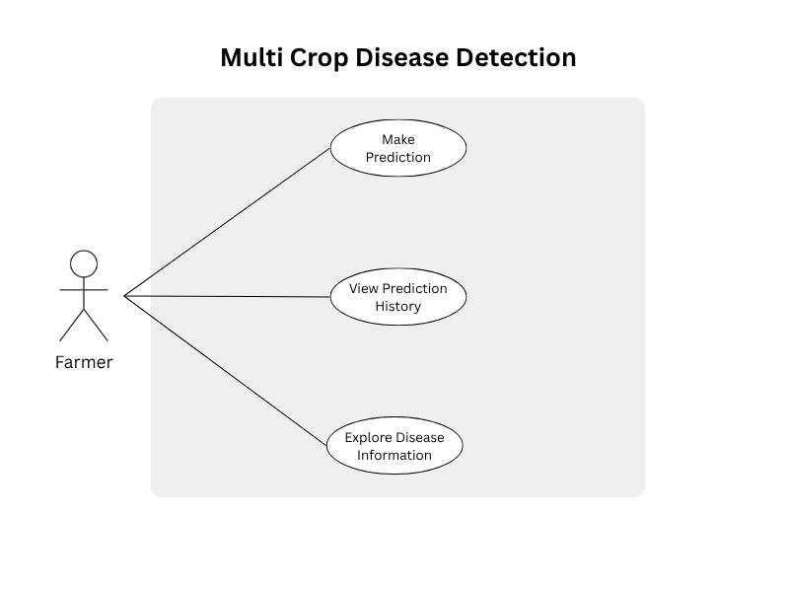
Figure 2: Use Case-2: View Detection History and Disease Details

Entity-Relationship Diagram (ERD)
This section provides a detailed explanation of the Conceptual Entity-Relationship Diagram (ERD) for the Multi Crop Disease Detection System. An ERD is a high-level data model that illustrates the main entities (things or concepts) within a system and the relationships between them. For a conceptual ERD, the focus is on understanding the data structure from a business perspective, independent of any specific database implementation.

Purpose of the Diagram
The primary purpose of this Conceptual ERD is to:
- Identify the key data entities relevant to the system's operation, particularly concerning model training, evaluation, and administration.
- Illustrate the logical relationships that exist between these entities.
- Provide a clear, high-level overview of the data landscape, which is crucial for understanding the system's underlying information structure.

Entities
Entities are the fundamental "things" or objects about which the system stores information. In this diagram, represented by rectangles, we have the following entities:

- Admin:
  - Description: Represents an administrator or a user with privileges to manage and oversee the machine learning aspects of the system. This includes managing datasets, developing model architectures, and reviewing model performance.
  - Conceptual Attributes (Examples): AdminID, Name, Email, Role.

- Dataset:
  - Description: Represents a collection of data (e.g., images of crops, labels) used for training, validating, or testing the machine learning models.
  - Conceptual Attributes (Examples): DatasetID, Name, Description, Size, CreationDate.

- Model Architecture:
  - Description: Represents the design or blueprint of a machine learning model, such as your Branched CNN. This entity defines the structure, layers, and configurations of the model before it is trained.
  - Conceptual Attributes (Examples): ArchitectureID, Name, Version, Description, ArchitectureDetails (e.g., JSON representation of layers).

- Model:
  - Description: Represents a specific trained instance of a Model Architecture. This is the actual model that has been trained on a Dataset and is ready for inference or evaluation. (Previously referred to as "Trained Model Instance").
  - Conceptual Attributes (Examples): ModelID, ArchitectureID, TrainingDate, TrainingDuration, DeploymentStatus.

- Performance:
  - Description: Represents the results of an evaluation conducted on a specific Model. This includes various metrics (e.g., accuracy, precision, recall, F1-score) that quantify the model's effectiveness.
  - Conceptual Attributes (Examples): PerformanceID, EvaluationDate, MetricName, MetricValue, EvaluationDatasetID

Relationships
Relationships are associations between two or more entities, indicating how they are connected or interact. These are represented by diamond shapes in the diagram.

- manages:
  - Connects: Admin and Dataset
  - Description: An Admin is responsible for managing one or more Datasets.
  - Cardinality:
    - An Admin can manage many Datasets (1:N).
    - A Dataset is managed by one Admin (1).
- develops:
  - Connects: Admin and Model Architecture
  - Description: An Admin develops or designs one or more Model Architectures.
  - Cardinality:
    - An Admin can develop many Model Architectures (1:N).
    - A Model Architecture is developed by one Admin (1).
- Trains:
  - Connects: Dataset and Model
  - Description: A Dataset is used to train one or more Models (trained instances).
  - Cardinality:
    - A Dataset can train many Models (1:N).
    - A Model (trained instance) is trained by one Dataset (1).
- Instantiates: (This relationship is implied and crucial for clarity, even if not explicitly drawn in your current diagram, it connects the blueprint to the actual trained model)
  - Connects: Model Architecture and Model
  - Description: A Model Architecture serves as the blueprint from which one or more Models (trained instances) are created.
  - Cardinality:
    - A Model Architecture can instantiate many Models (1:N).
    - A Model (trained instance) instantiates from one Model Architecture (1).
- Evaluates:
  - Connects: Model and Performance
  - Description: A Model (trained instance) is evaluated to produce Performance metrics.
  - Cardinality:
    - A Model can have many Performance evaluations (1:N) (e.g., evaluated multiple times, or for different metrics).
    - A Performance record is produced by one Model (1).

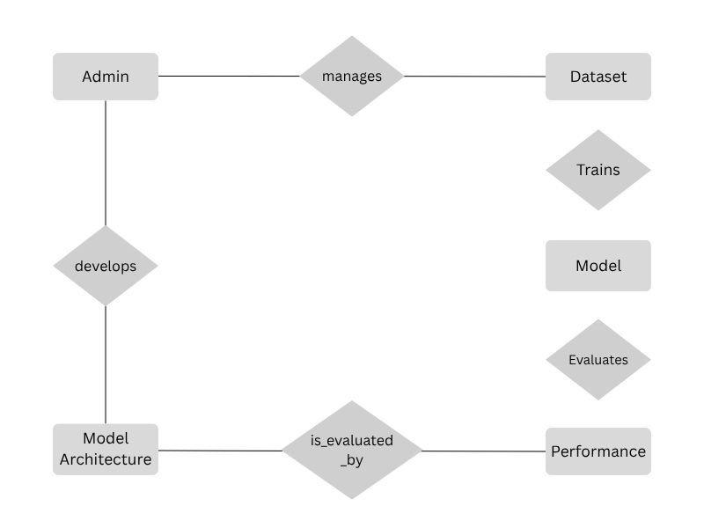
Figure 3: Entity-Relationship Diagram (ERD) for Model Training and Evaluation

Sequence Diagram
This sequence diagram shows the detailed flow of operations from the moment a user selects or captures a plant leaf image to when the system returns the disease prediction. It involves key components such as the mobile frontend, the FastAPI backend, the trained CNN model for prediction, and optional components like Cloudinary for image upload and saliency map generation for interpretability. The diagram captures both synchronous and asynchronous interactions between system components.

Purpose of the Diagram
The primary purpose of this Sequence Diagram is to:
- Illustrate the dynamic behavior and flow of messages for the "Make Prediction" use case.
- Show the exact order in which messages are exchanged between the key components of the system.
- Detail the interactions between the User (Farmer), Server, CNN Model, and Cloudinary during a prediction request.
- Provide a clear visual representation of the system's operational workflow for its core functionality.

Participants
Participants (or Lifelines) in a sequence diagram represent the objects or roles that interact with each other over time. Each participant has a vertical dashed line (lifeline) representing its existence over time, and activation bars (rectangles) indicating periods when the participant is active.

- User (Farmer):
  - Description: The human actor initiating the crop disease prediction process. This represents the farmer interacting with the mobile application.
  - Role: Initiates the image upload, provides the input image, and receives the final prediction results.

- Server:
  - Description: The backend application server (hosting the FastAPI application). This acts as the central orchestrator, handling requests from the mobile app, interacting with the CNN model, and managing storage with Cloudinary.
  - Role: Receives image uploads, forwards images to the model, receives model outputs, manages image storage, and sends final results back to the user.

- Custom Branched CNN Model:
  - Description: The core machine learning component (Branched CNN model) responsible for analyzing crop images and predicting diseases.
  - Role: Receives images from the server, performs inference, and returns prediction results along with saliency maps.

- Cloudinary:
  - Description: The external cloud-based service used for storing and managing images and saliency maps.
  - Role: Receives images/saliency maps for storage and provides accessible links (URLs) for the stored content.

Message Flow (Interaction Sequence)
The diagram illustrates the following sequence of messages and interactions:
- Upload Image (User (Farmer) to Server):
  - Description: The process begins when the User (Farmer) selects a crop image on their mobile device and initiates an upload request to the Server. This is the initial trigger for the prediction process.

- Provide Image (Server to CNN Model):
  - Description: Upon receiving the image from the user, the Server then forwards this Image to the CNN Model for analysis. This represents the server acting as an intermediary for the ML inference request.

- Prediction and Saliency Maps (CNN Model to Server):
  - Description: After processing the image, the CNN Model returns two key pieces of information to the Server: The Prediction (e.g., disease classification, confidence score) and the Saliency Maps (visual explanations highlighting influential regions in the image).

- Image and Saliency Maps (Server to Cloudinary):
  - Description: The Server then sends both the original Image (or a processed version) and the generated Saliency Maps to Cloudinary for persistent storage. This ensures that these visual assets are archived and accessible via URLs.

- Image and Saliency Maps Links (Cloudinary to Server):
  - Description: After successfully storing the visual assets, Cloudinary responds by sending back the Links (URLs) to these stored Image and Saliency Maps to the Server. These links are crucial for accessing the content later.

- Prediction results + Saliency Map Links (Server to User (Farmer)):
  - Description: Finally, the Server consolidates the Prediction results received from the CNN Model and the Saliency Map Links received from Cloudinary. It then sends this combined information back to the User (Farmer)'s mobile application for display. This concludes the primary interaction flow for a single prediction request.

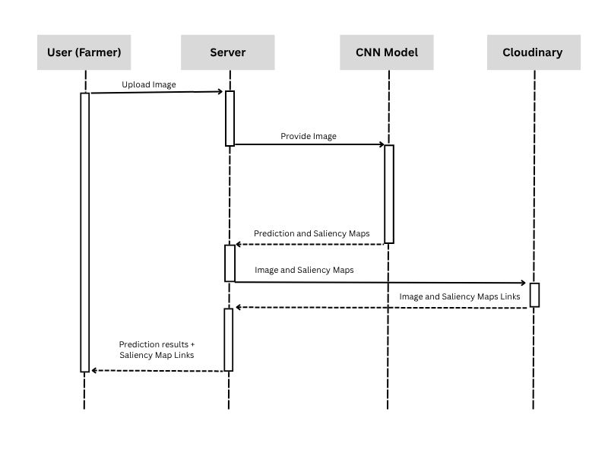
Figure 4: Sequence Diagram - Real-Time Disease Detection Workflow

Design Models

Component diagram
This section provides a detailed explanation of the Component Diagram for the Multi Crop Disease Detection System. A Component Diagram is a type of UML (Unified Modeling Language) structural diagram that shows the system's software components and the relationships between them. It provides a high-level, modular view of the system's architecture, focusing on the logical parts of the system and how they connect to one another.

Purpose of the Diagram
The primary purpose of this Component Diagram is to:
- Identify the major modular components of the system.
- Illustrate the internal structure of the application at a component level.
- Show the dependencies and interfaces between these components.
- Provide a clear overview of how the different pieces of the software fit together to form the complete system.

Components
Components are a modular, replaceable, and reusable part of the system that encapsulates its implementation and provides a set of interfaces. In this diagram, we have the following key components.

- Mobile App:
  - Description: This is the front-end user interface of the system, developed using React Native. It runs on the user's Android device.
  - Role: Provides the user with a graphical interface to upload images, view prediction results, and access other functionalities like viewing history and exploring disease information. It initiates all communication with the backend.

- FastAPI App:
  - Description: This is the core backend component, deployed on the Hugging Face platform. It is a RESTful API server built with the FastAPI framework.
  - Role: Acts as the central orchestrator of the system. It handles incoming requests from the Mobile App, manages communication with the Branched CNN Model for predictions, and interacts with Cloudinary for image storage. It consolidates all the information and sends the final response back to the user.

- Branched CNN Model:
  - Description: The machine learning component of the system. This is a trained Convolutional Neural Network (CNN) that performs the actual crop disease detection and generates saliency maps. It is also deployed within the Hugging Face environment.
  - Role: Receives an image from the FastAPI App, performs inference, and returns a prediction result along with the visual saliency map data.

- Cloudinary Server:
  - Description: An external, third-party cloud-based service for image and video management.
  - Role: Provides image storage services. It receives images and saliency maps from the FastAPI App and returns unique, publicly accessible URLs for the stored content.

Component Interactions and Dependencies
The arrows and lines in the diagram represent the communication and dependencies between the components.

- Mobile App to FastAPI App:
  - Description: The Mobile App has a dependency on the FastAPI App. The mobile application sends a request (e.g., an image upload) to the backend API.
  - Interaction: This is a request-response interaction initiated by the user.

- FastAPI App to Branched CNN Model:
  - Description: The FastAPI App has a dependency on the Branched CNN Model for its core functionality. It sends an image for prediction.
  - Interaction: This is an internal function call within the Hugging Face server environment, where the FastAPI App utilizes the Branched CNN Model to process the data.

- FastAPI App to Cloudinary Server:
  - Description: The FastAPI App has a dependency on the Cloudinary Server for image storage. It sends image data and receives URLs in return.
  - Interaction: This is a standard API call to an external service. The FastAPI App sends a request to store an image and Cloudinary responds with the storage link.

Logical Grouping
The components FastAPI App and Branched CNN Model are grouped together within a larger container labeled "Hugging Face Server". This grouping visually represents that these two components are deployed together in the same physical or virtual environment, which allows for fast and efficient internal communication between them.

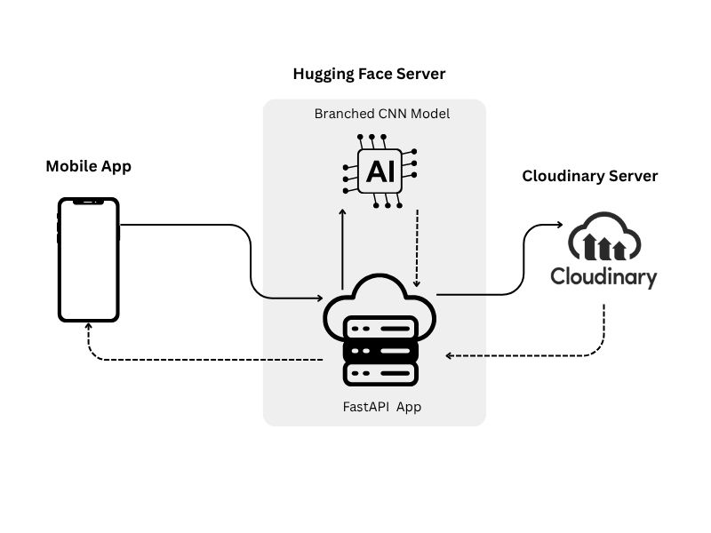
Figure 5: Component Diagram - System Architecture Overview

Deployment Diagram
This section provides a detailed explanation of the Deployment Diagram for the Multi Crop Disease Detection System. A Deployment Diagram is a type of UML (Unified Modeling Language) structural diagram that shows the physical architecture of a system. It illustrates the physical layout of hardware nodes, the software components that are deployed on them, and the communication paths between them.

Purpose of the Diagram
The primary purpose of this Deployment Diagram is to:
- Identify the physical hardware and software nodes that make up the system's runtime environment.
- Illustrate which software components are deployed on which nodes.
- Show the communication links and protocols used to connect the different nodes.
- Provide a complete picture of the system's physical architecture, which is essential for understanding how the application runs in a real-world setting.

Nodes
Nodes are physical or logical pieces of hardware where software components are deployed. These are represented by the gray boxes in the diagram.

- Android Mobile App (React Native):
  - Type: A physical hardware device (e.g., a smartphone or tablet) belonging to the user.
  - Description: This node runs the front-end application developed with React Native. It is where the user interacts directly with the system.

- Hugging Face Server:
  - Type: A logical server environment in the cloud.
  - Description: This node is the core back-end server, which hosts both the FastAPI Backend and the Crop Disease Model. It serves as the processing hub for all prediction requests.

- Cloudinary:
  - Type: An external cloud-based service.
  - Description: This node represents the third-party server environment provided by Cloudinary, dedicated to image and saliency map storage.

Deployed Components
This section details which software components from the Component Diagram are deployed on each node of the Deployment Diagram.

- On the Android Mobile App node:
  - The Android Mobile App component itself is deployed here.

- On the Hugging Face Server node:
  - The FastAPI Backend component is deployed here to handle API requests and business logic.
  - The Crop Disease Model component is also deployed here, allowing the backend to call the model internally for inference.

- On the Cloudinary node:
  - Cloudinary is a service, not a component we deploy. This node represents the service itself, which our system interacts with.

Communication Links
The lines between the nodes represent the communication paths, often labeled with the protocol used.

- Android Mobile App to Hugging Face Server:
  - Description: This link represents the secure communication channel between the user's mobile application and the backend server.
  - Protocol: HTTPS (Hypertext Transfer Protocol Secure). This ensures that all data transmitted between the app and the server, including images and prediction results, is encrypted and secure.

- Hugging Face Server to Cloudinary:
  - Description: This link represents the communication between our backend and the external Cloudinary service for storing visual assets.
  - Protocol: API Call. This is a standard programmatic request made by the FastAPI Backend to Cloudinary's API to upload images and retrieve their storage URLs.

- Internal Communication within Hugging Face Server:
  - Description: An internal link exists between the FastAPI Backend and the Crop Disease Model within the Hugging Face Server node.
  - Protocol: API Call. The FastAPI Backend makes an internal API call to the Crop Disease Model to pass an image and get a prediction. The close proximity of these components within the same environment allows for extremely fast communication.

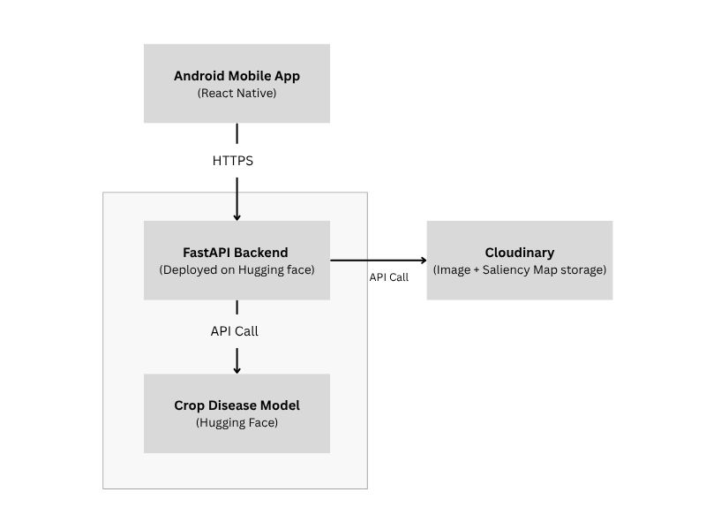
Figure 6: Deployment Diagram - Physical System Architecture

Screenshots

Home Screen
This screen allows the user to start the disease detection process by selecting or capturing an image of an affected crop.

Workflow
- The user taps the camera icon to take a photo or selects one from the device gallery.
- The selected image is sent to the backend (FastAPI) which forwards it to the deep learning model hosted on Hugging Face.
- After processing, the app displays:
  - Original Uploaded Image
  - Saliency Map (Raw): a grayscale map showing activated areas
  - Overlay Map: saliency overlaid on the original image for interpretability
  - Predicted Disease Name
  - Confidence Score

This screen also maintains a clean and user-friendly layout that ensures even non-technical users (like farmers) can easily interpret results.

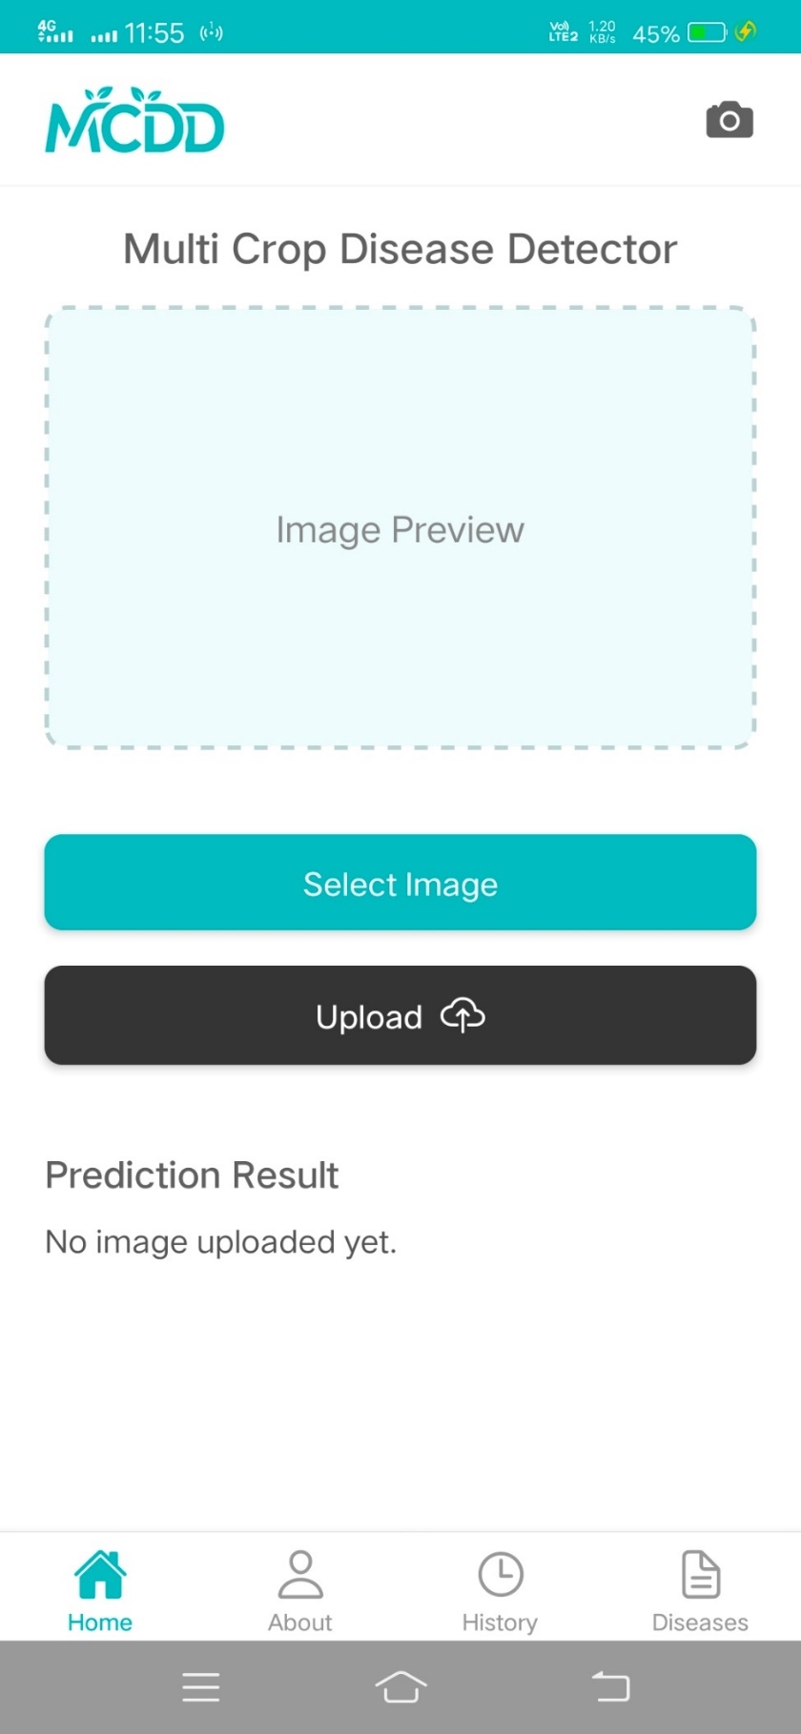
Figure 7: Home Screen
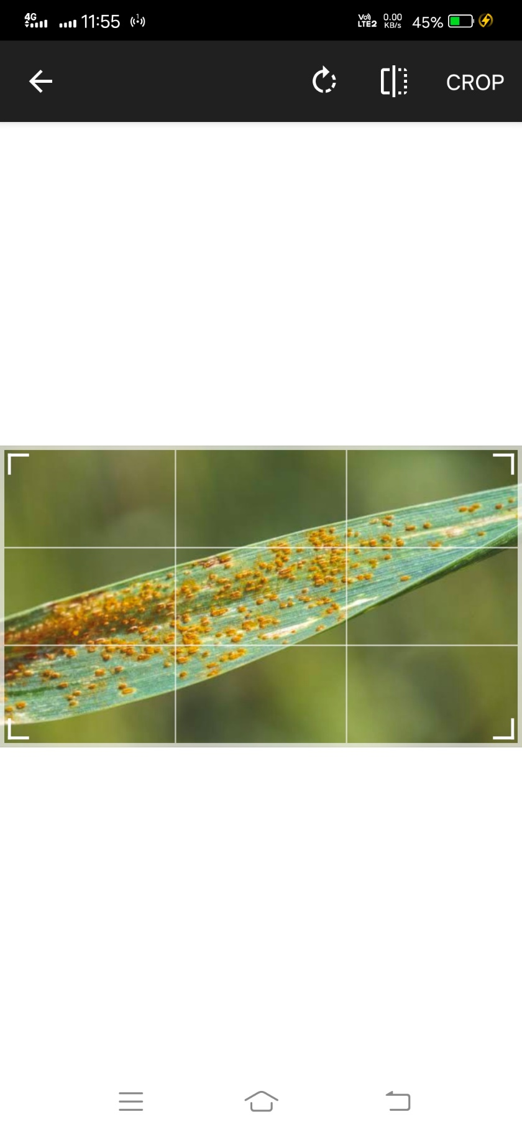
Figure 8: Home Screen - Selecting the Image

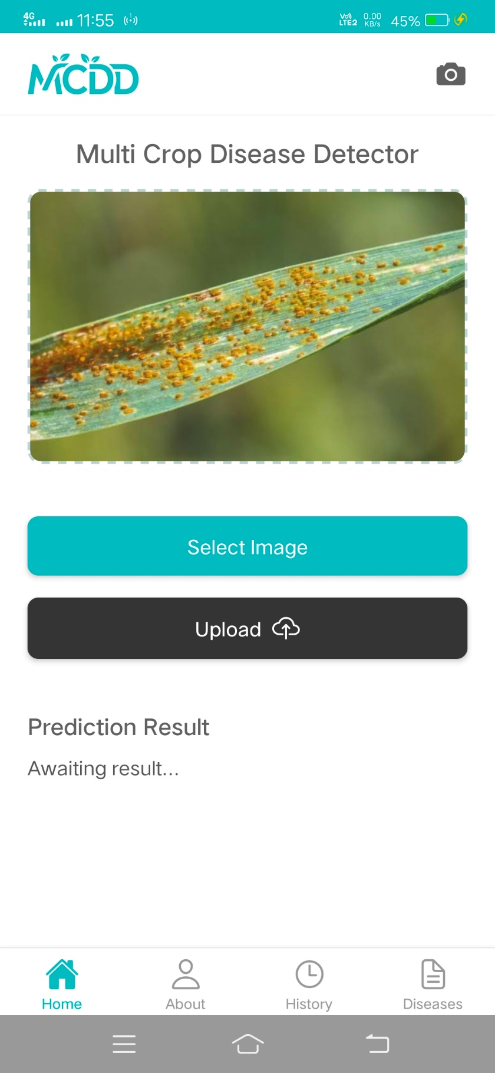
Figure 9: Home Screen - Selected Image Loaded, Awaiting Upload for Detection
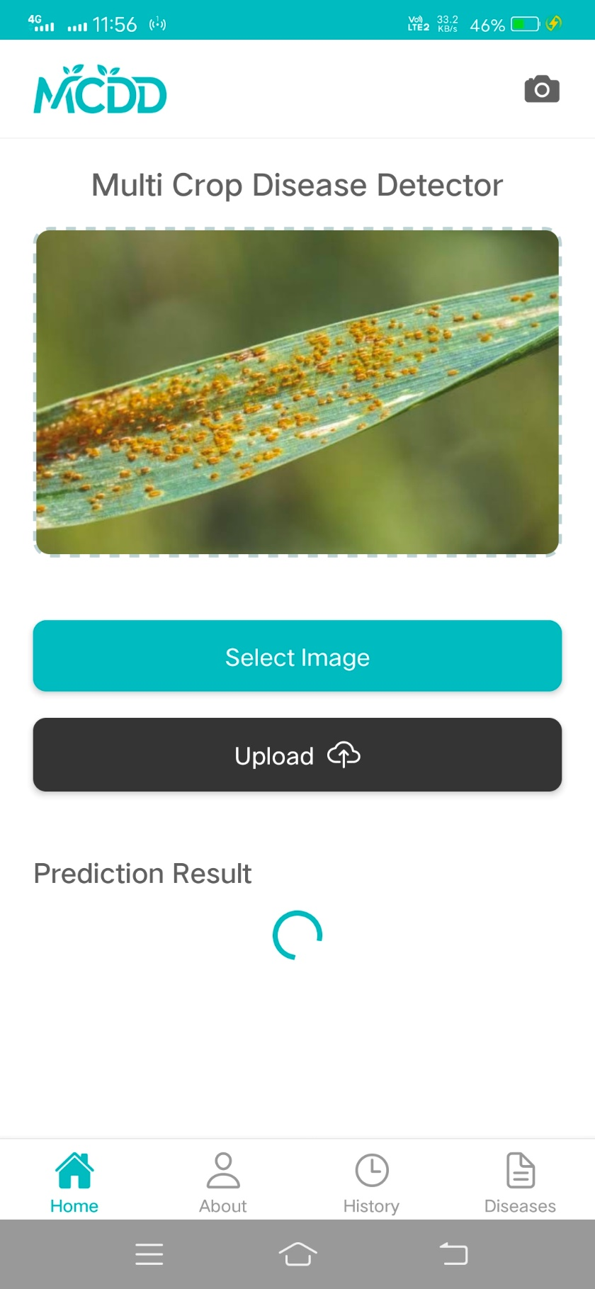
Figure 10: Home Screen - Image Uploaded, Awaiting Prediction Results
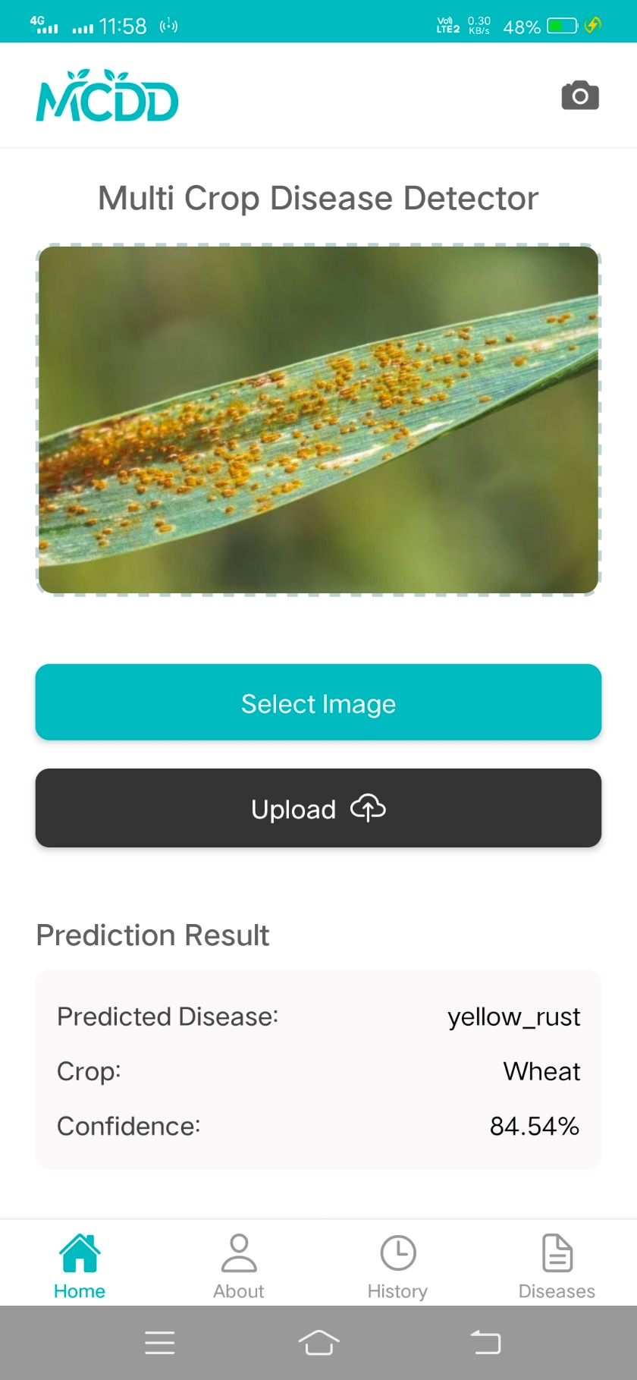
Figure 11: Home Screen - Prediction Result
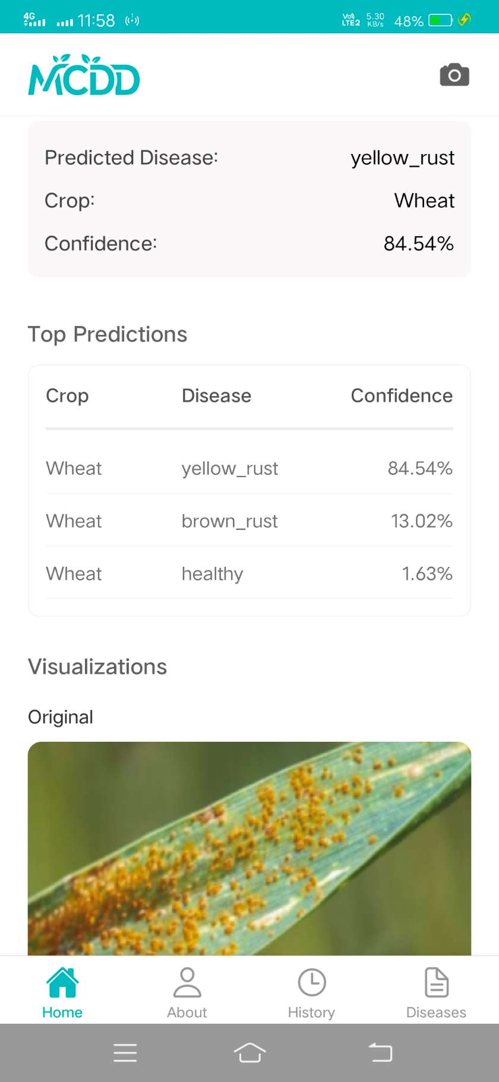
Figure 12: Home Screen - Prediction Result with top 3 predictions
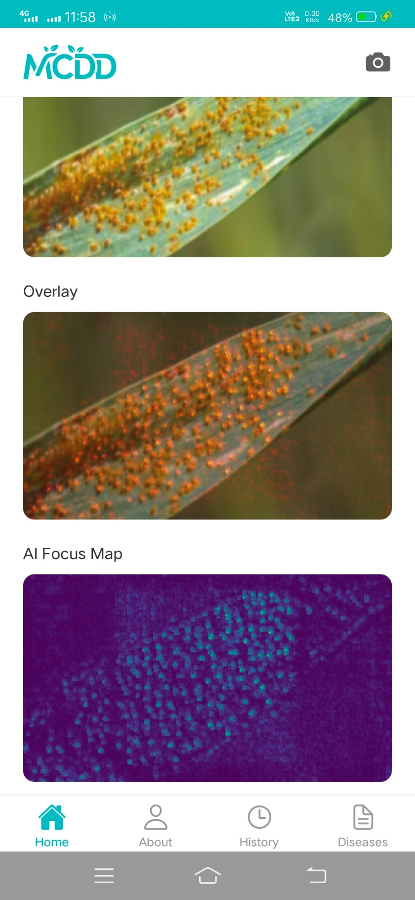
Figure 13: Home Screen - Saliency Maps

About Screen
This screen introduces the application and development team to the user. It includes key statistics about the project, a detailed overview of the team behind the solution, the vision and purpose of the app, acknowledgments, and contact details for support or feedback.

Workflow
- The screen opens with a branded header featuring the app logo and a short subtitle describing its purpose: “AI Assistant for Farmers.”
- A horizontal stat panel highlights:
  - The number of supported crops
  - The total number of detectable diseases
  - The promise of instant detection results

- A scrollable team section displays each team member's:
  - Photo
  - Name, role, and email
  - Social icons (LinkedIn & GitHub) that open in the browser when tapped

- Below the team section, the project overview is presented using two cards:
“Final Year Project”, briefly explaining what the app does
“Our Vision”, focusing on the mission to empower farmers with affordable AI tools
- The acknowledgment section thanks the project supervisor and supporting faculty.
- At the bottom, the contact CTA invites users to provide feedback or ask questions, linking directly to the developer’s email.
- The screen ends with a footer showing version information, update date, and copyright.

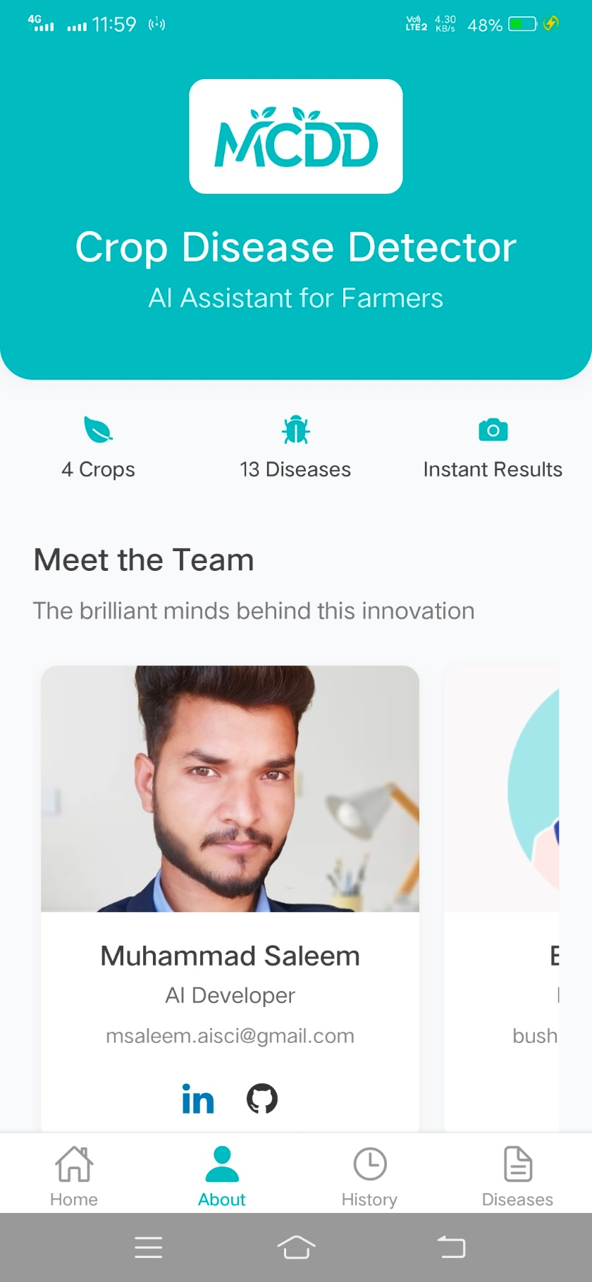
Figure 14: About Screen
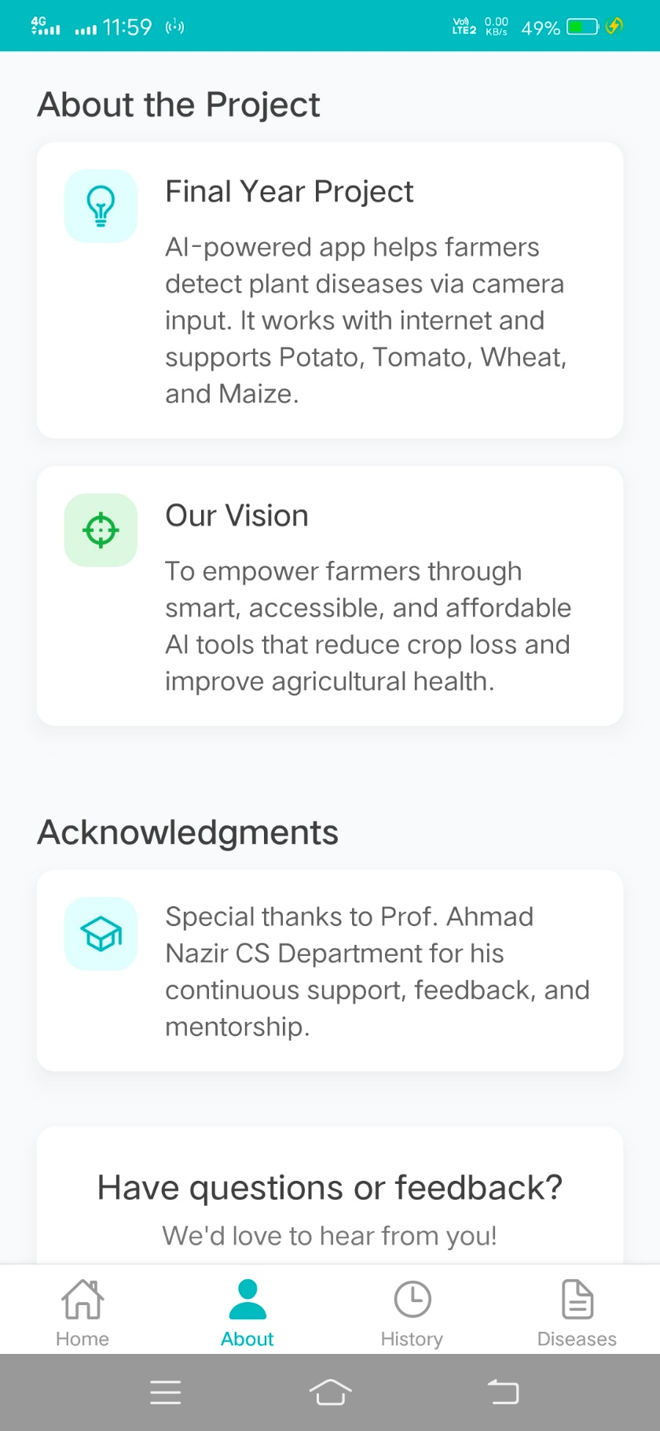
Figure 15: About Screen - About the project

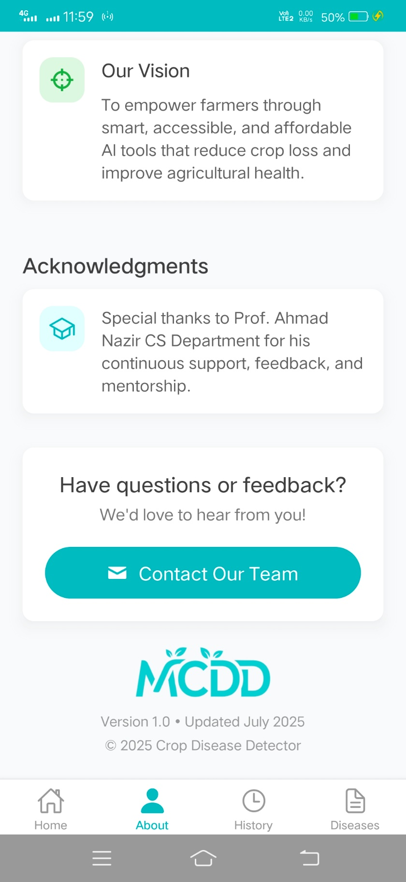
Figure 16: About Screen - Feedback/ Get in touch

History Screen
This screen allows the user to view previously uploaded images and their corresponding disease predictions. It maintains a local history of predictions using AsyncStorage and provides an option to clear the stored data.

Workflow
- When the screen is opened, the app attempts to load the stored prediction history from the device's local storage (AsyncStorage).
- If no saved history exists, the screen loads mock data as a placeholder (used for development/testing purposes).
- Each history entry displays:
  - Uploaded Image
  - Predicted Crop
  - Disease Name
  - Prediction Confidence
  - Timestamp
- The entries are presented in a vertically scrollable card layout.
- If the user taps the trash icon in the top-right corner:
  - A confirmation alert is shown asking whether to clear the entire history.
  - Upon confirmation, all stored predictions are deleted and the screen updates to show an empty state.
- If no predictions are present, a message "No predictions yet." is displayed in the center of the screen.

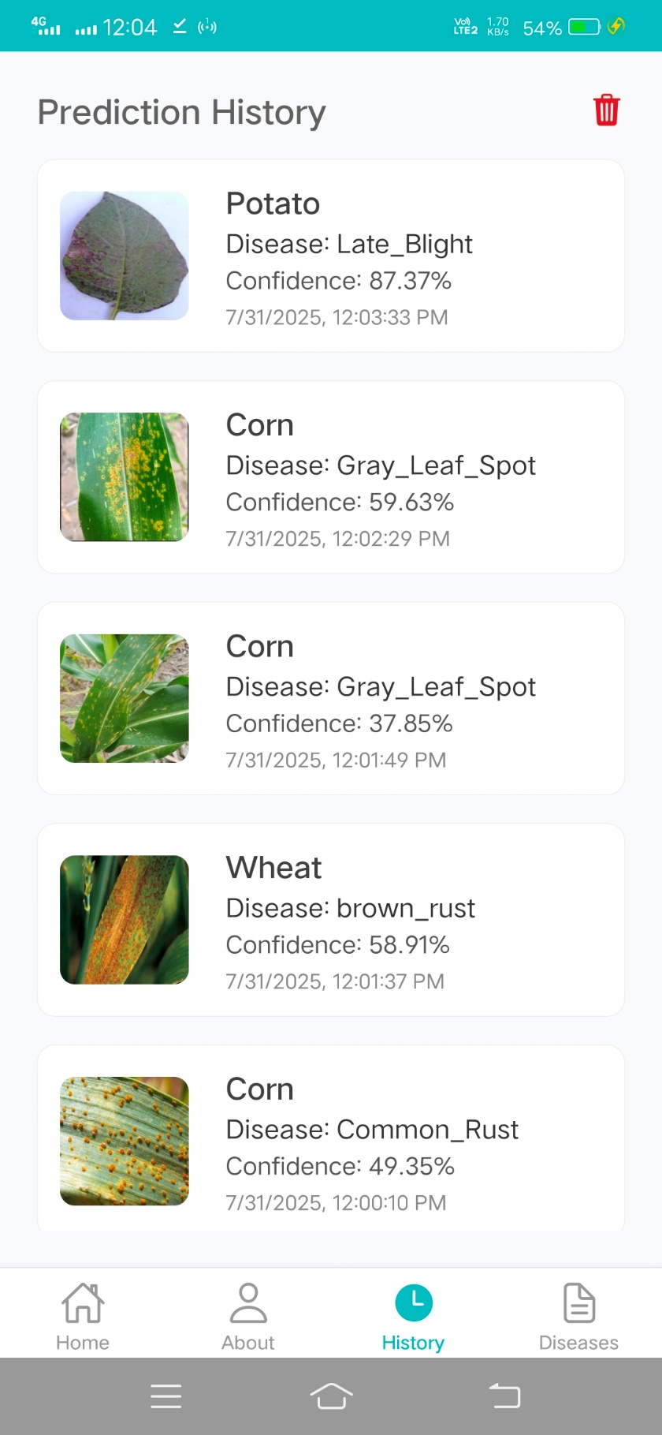
Figure 17: History Screen

Diseases Screen
This screen displays a categorized list of plant diseases grouped by crop (Corn, Potato, Wheat, Tomato). It provides visual identification of each disease along with its severity level and allows users to explore further details.

Workflow
- Upon opening the screen, the app dynamically generates disease cards grouped by crops.
- Each card shows:
  - Disease Name
  - Crop Name
  - Severity Level (High, Medium, Low)
  - Thumbnail Image of the disease-affected leaf

- The user can scroll vertically to browse all diseases under all crops.
- When the user taps a disease card:
  - The app navigates to the Details Screen, passing disease name, crop name, and the image via route parameters.

- The layout uses color-coded severity tags for quick visual understanding:
  - High → Red
  - Medium → Orange
  - Low → Green

This screen serves as a disease reference guide for farmers and researchers, improving disease identification and awareness.

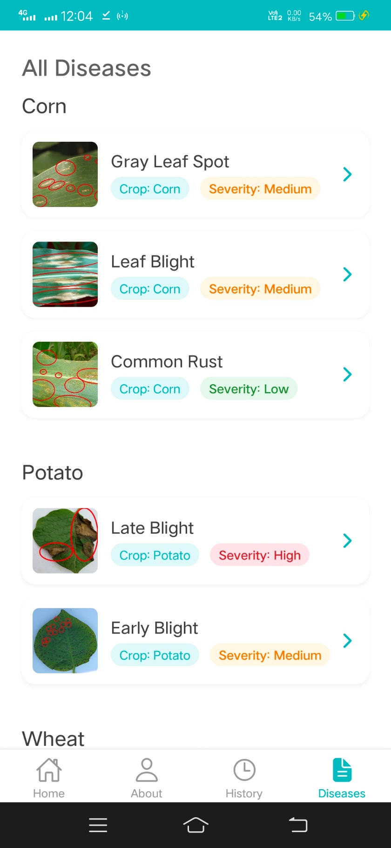
Figure 18: Disease Screen/ Corn, Potato
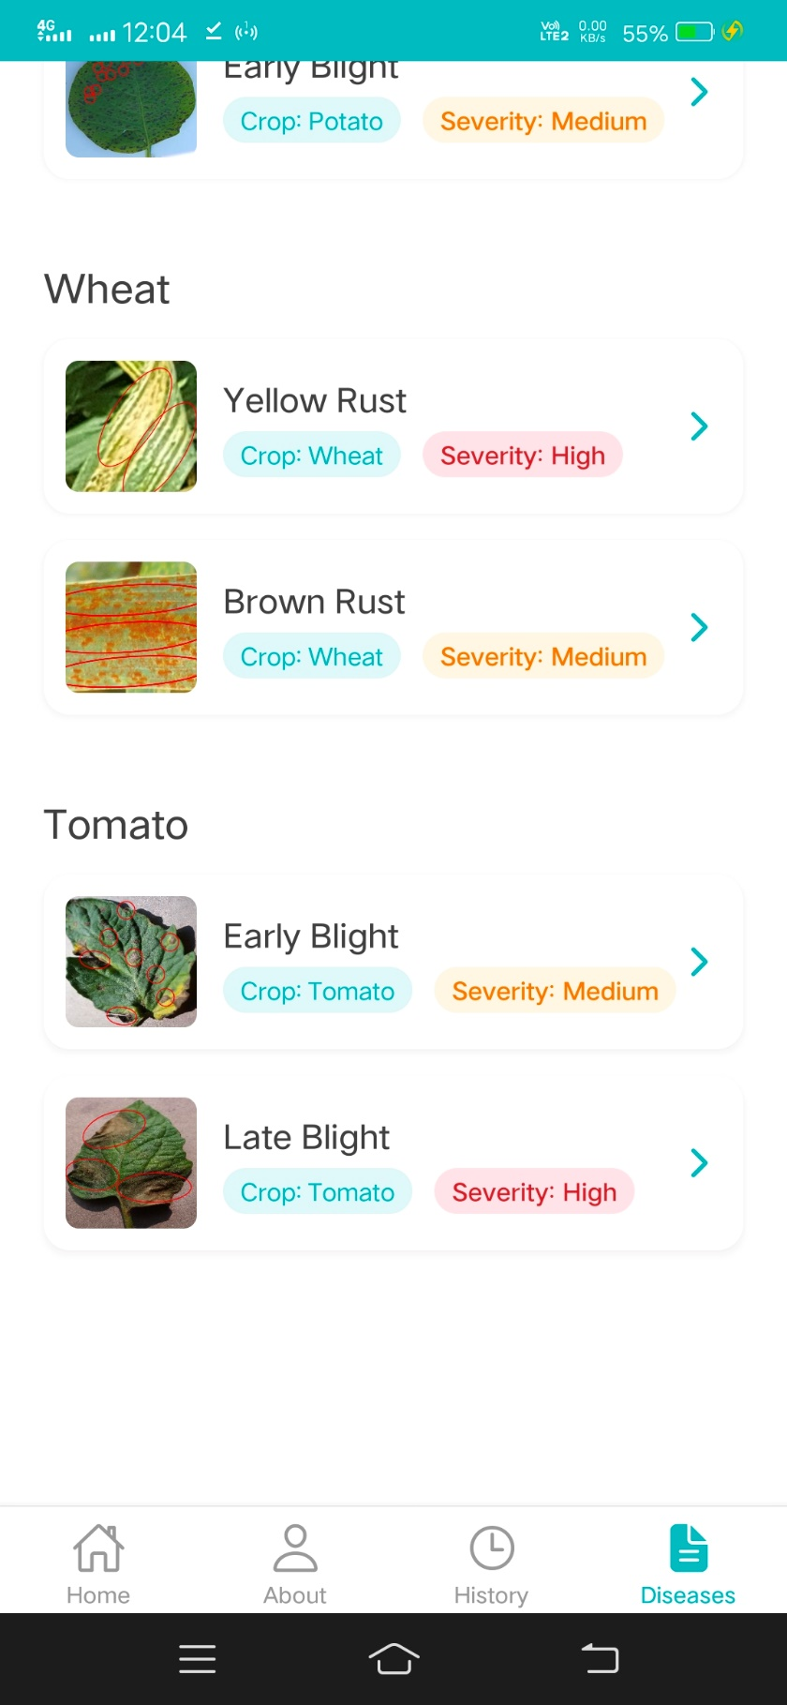
Figure 19: Disease (Wheat, Tomato)

Details Screen
This screen provides in-depth information about a detected or selected disease, including symptoms, causes, and recommended treatments or preventions. It enhances user understanding and supports informed decision-making by farmers.

Workflow
- The screen is opened when the user taps on a disease from the All-Diseases screen or Prediction Results.
- The following parameters are passed via navigation:
  - disease: Name of the disease
  - img: Image URL of the affected crop
  - crop: Name of the crop

- The screen displays:
  - Disease Title (e.g., Late Blight)
  - Disease Image (received via img param)
  - Crop Tag (e.g., Crop: Potato)
  - Severity Tag (static or dynamic if implemented)

- Information is fetched from a local object disease_data using the key ${crop}-${disease}.
- Three collapsible cards display:
  - Symptoms: Key visual or physical signs on crops
  - Causes: Environmental and biological sources of disease
  - Treatment & Prevention: Recommended actions to control or prevent disease

- Each card includes:
  - Section icon
  - Title (e.g., Symptoms)
  - Bullet points of data pulled from disease_data

- A back button is provided at the top-left for navigation to the previous screen.

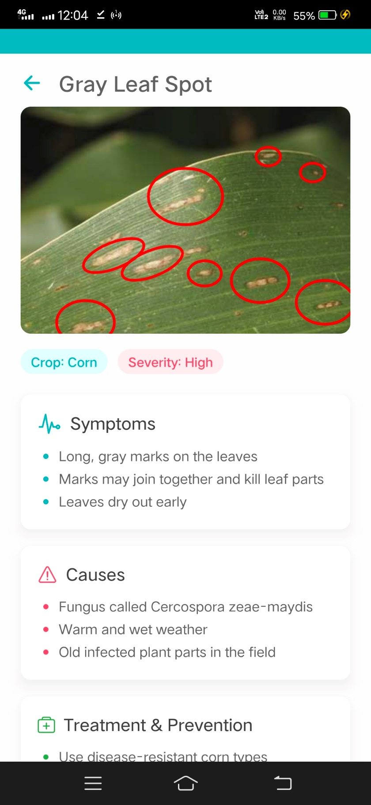
Figure 20: Disease Details
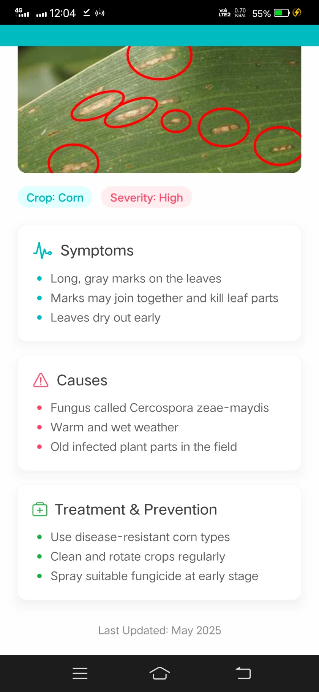
Figure 21: Disease Details

Test Cases

Test Case 1: Image Upload and Prediction

Identifier | TC-1
Priority | High
Related requirements(s) | UC-1, Section 2.2.1
Short description | Test the process of uploading an image and receiving a disease prediction.
Pre-condition(s) | - Device is connected to the internet  - App is installed and opened  - User has access to a leaf image (camera or gallery)
Input data | Valid image of a diseased crop (e.g. Potato with Late Blight)
Detailed steps | - Launch the app  - Tap the camera or gallery icon  - Select a valid image  - Image is sent to backend  - Wait for the response  - View prediction result and saliency maps
Expected result(s) | System displays:  - Uploaded image  - Raw saliency map  - Overlay saliency map  - Predicted disease  - Confidence score
Post-condition(s) | Prediction is stored in history
Table 6.1: TC-1: Image Upload and Prediction

Test Case 2: View Detection History and Disease Details

Identifier | TC-2
Priority | Medium
Related requirements(s) | UC-1, Section 2.2.2
Short description | Test the ability to view stored prediction history and see detailed disease information
Pre-condition(s) | - At least one prediction result already exists  - App is running and accessible
Input data | Stored prediction entries with disease names, timestamps, and images
Detailed steps | - Open the app  - Navigate to the “History” screen  - Tap any prediction entry  - Observe the disease details shown  - View prediction result and saliency maps
Expected result(s) | System displays:  - History is displayed in scrollable format  - Each item shows crop, disease, confidence, and timestamp  - Tapping a disease shows its symptoms, causes, and treatments
Post-condition(s) | User understands the disease and how to treat/prevent it  No crash or unexpected behavior
Table 6.2: TC-2: View Detection History and Disease Details

Test Case 3: Viewing Saliency Map Overlays

Identifier | TC-3
Priority | Medium
Related requirements(s) | UC-1, Section 2.2.2
Short description | Test the ability to correctly display the saliency maps and overlays for interpretability after prediction.
Pre-condition(s) | - User has selected and uploaded an image  - The backend has returned a valid prediction with saliency map URLs
Input data | A crop leaf image (e.g., Tomato with Early Blight)
Detailed steps | - Open the app  - Navigate to the Home screen  - Select or capture a leaf image  - Tap the "Upload Image" button  - Wait for the result to appear  - Observe the three images shown after prediction
Expected result(s) | The following three images are displayed clearly:  - Original Image (as uploaded by the user)  - Raw Saliency Map (grayscale highlighting key areas used by model)  - Overlay Map (original image blended with saliency for interpretability)
Post-condition(s) | - User understands which region of the crop leaf led to the AI prediction  - Result and images are stored in history for future review
Table 6.3: TC-3: Viewing Saliency Map Overlays

References
- Dolatabadian, Aria, et al. "Image‐based crop disease detection using machine learning." Plant Pathology 74.1 (2025): 18-38.
- Panchal, A. V., et al. "Image-based plant diseases detection using deep learning." Materials Today: Proceedings, 80 (2023): 3500-3506.
- Dolatabadian, A., et al. "Image‐based crop disease detection using machine learning." Plant Pathology, 74(1), 18-38.
- Upadhyay, & Gupta. “Enhanced ResNeXt-based model for fungal diseases in apple; AI surveys across crops.” Scientific Reports, 2025.
- Past, present and future of deep plant leaf disease recognition. [ScienceDirect], 2025.
- Image-based blight disease detection using ensemble deep. [ScienceDirect], 2025.
- Robust crop disease detection using multi-domain data. [ScienceDirect], 2025.
- Plant Disease Detection Using Deep Learning Techniques. ICCK, 2025.
- An efficient plant disease detection using transfer learning approach. Scientific Reports, 2025.
- Potato plant disease detection: hybrid deep learning. (EfficientNetV2B3 + ViT), 2025.
- Smartphone-based lightweight system (DenseNet201 + Teachable Machine) – IJSAT, 2025.
- Slender-CNN model for corn, rice, and wheat multi-crop disease detection. Plant Methods, 2025.
- Advancing plant leaf disease detection integrating ML. Scientific Reports, 2024.
- Deep learning and computer vision in plant disease detection. Springer AI Review, 2024.
- Advances in Deep Learning Applications for Plant Disease and Pest Detection. Remote Sensing, 2025.
- Dual RNN Architecture for Crop Disease Detection: Improved Patch. Wiley, 2025.
- MSFNet-CPD: Multi-Scale Cross-Modal Fusion Network for Crop Pest Detection. arXiv preprint, 2025.
- Dataset: Plant Village Dataset – Kaggle
- Dataset: Plant Diseases Training Dataset - Kaggle
- Dataset: Five Crop Diseases Dataset – Kaggle

